# SMDE First assignement (20% of the final mark, individual)

## First question: generate a random sample (15% of the FIRST ASSIGMENT).

On this exercise, we are going to start working with probability distributions. The first work to do is to **generate more than 200 observation**s of a uniform distribution (RNG). We are going to generate this using code (Java C++, …).

To do so you can access to: <http://wiki.fib.upc.es/sim/index.php/Main_Page/en>

Explore the different alternatives that exists and select one to perform the codification of your RNG. The program must write the output in a text file that are suitable to be imported to R.

**Test the fitting** of the values with a new sample now generated by R (or a Spreadsheet like Excel). Use for the fitting a Chi-square test.

Is the sample generated by the RNG similar to the one generated on R (or in the Spreadsheet)? You can play with the distribution, changing the parameters.

Are you really comparing the quality of the RNG or the RVA?

Justify your answers.

### Some useful remarks:

Here you can find some useful tools and resources to solve this question.

**Some code**

#generation of a normal distribution.

v1=rnorm(200, mean=0, sd=1)

summary(v1)

#Work with the data as a dataframe.

taula_v1=data.frame(x1=v1)

#Definition of the intervals, categories to be used.

taula_v1_cat=transform(taula_v1, cat = ifelse(x1 < -1,"-1",

ifelse(x1 < -0.5,"-0.5",

ifelse(x1 < 0,"0",

ifelse(x1 < 0.5,"0.5",

ifelse(x1 <1,"1","Inf"))))))

#Counting the amount of elements in each category “table” function.

taula_freq_v1=as.data.frame(with(taula_v1_cat, table(cat)))

The code for the Chisquare (remember that we need to **create the taula_freq** with two columns, the occurrences for each category on the both distributions).

Test=chisq.test(taula_freq, correct=FALSE)

Also, remember, to generate the data in an Spreadsheet, we need to copy the samples to use in a column that is not going to change.

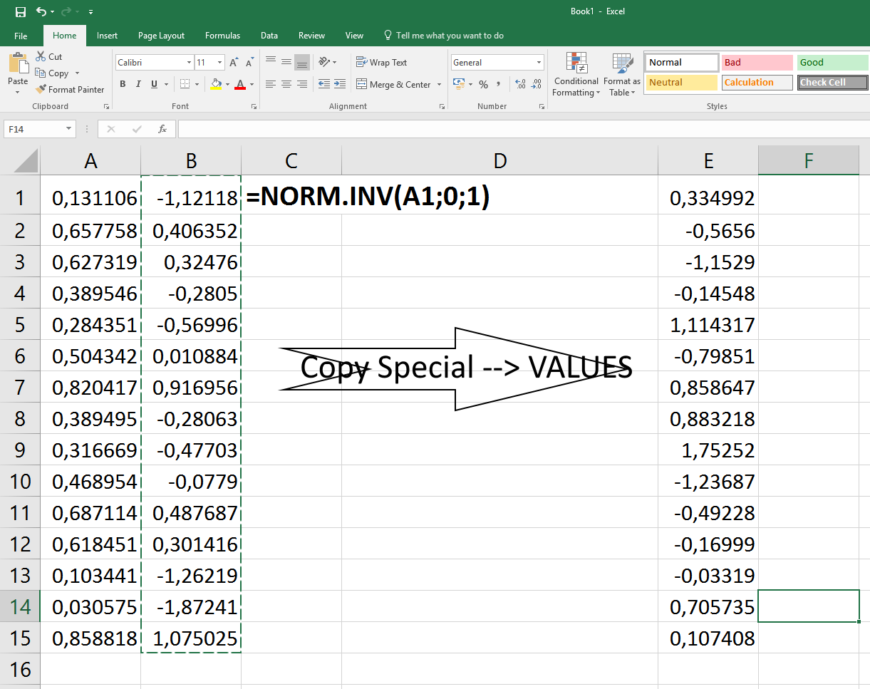

**6.998912666125008E-4**

**0.00568194558993566**

**0.8109604441888623**

**0.282525962698679**

**0.7438747401752367**

**0.09178073180864783**

**0.18481307307044548**

**0.9821673999239586**

**0.3154952360119459**

**0.12569037269532773**

**0.9395551601802884**

**0.07274932637479155**

**0.27670981184827315**

**0.5428631185715551**

**0.26359319313637597**

**0.7241147659995611**

**0.35758302154101657**

**0.7605340404658425**

**0.15488920059870004**

**0.6317429849422711**

**0.8640269109353187**

**0.8772889305325573**

**0.11099675928001641**

**0.23602676712986562**

**0.9937892926057462**

**0.6389005539744828**

**0.5268878942426125**

**0.37318958012975717**

**0.3697301338385755**

**0.8776523640614136**

**0.9286074219997236**

**0.49598883089845874**

**0.31026471705287556**

**0.6929018865415608**

**0.37066724951768326**

**0.9349043737329557**

**0.4694744690393828**

**0.45419855230338385**

**0.04649505474733819**

**0.13553602537955053**

**0.7169783052023652**

**0.5405677623123075**

**0.07097830967064822**

**0.11827275385680361**

**0.9806823193460565**

**0.4370116375314654**

**0.45212900895990343**

**0.9603706024176494**

**0.907010231551288**

**0.5760057429057162**

**0.3882127860640498**

**0.46518415659104556**

**0.22219802121868737**

**0.40720074968303055**

**0.5217805137425553**

**0.10439244919919868**

**0.018281142104303063**

**0.09470167079681978**

**0.1765890223919414**

**0.5071372105253157**

**0.03839102427419374**

**0.564060176553376**

**0.7020199941216436**

**0.30857007814422405**

**0.38108869410579593**

**0.038995961684444226**

**0.09135412623433112**

**0.5106554709788036**

**0.35781465031396653**

**0.8192303859420721**

**0.5459648117609737**

**0.03904401227032096**

**0.9694708169090218**

**0.5885222380286853**

**0.11464090211186609**

**0.8553861496373933**

**0.9834722703056032**

**0.6136495934426839**

**0.34692122102969725**

**0.16003579288445005**

**0.4543089200152692**

**0.8526504932234015**

**0.8624520599820619**

**0.7965396171669702**

**0.7032057656535194**

**0.306651688847964**

**0.5548989903985473**

**0.28388872644500096**

**0.9343190472314987**

**0.436119535516106**

**0.1652864929681585**

**0.9145452491276351**

**0.702566963287077**

**0.8348340622174539**

**0.8748844549589873**

**0.5310639603139079**

**0.48730057373486085**

**0.910751787254543**

**0.6179128162403102**

**0.44649026065909037**

**0.1955975440751611**

**0.47042227010966864**

**0.1843363004416082**

**0.525059408275727**

**0.5581249695839815**

**0.8115784321391729**

**0.6191060851885256**

**0.22258574389331057**

**0.8072451494703003**

**0.013007396688830644**

**0.748094532484343**

**0.7813443888263449**

**0.05762651194137824**

**0.9163115458677323**

**0.5567908308989461**

**0.8749390438562878**

**0.7332502997074775**

**0.6265121285413868**

**0.5894020258466474**

**0.659513527258923**

**0.6795521996360847**

**0.8837114578612193**

**0.6521485659457005**

**0.9899932617577228**

**0.1125322998193885**

**0.5645058324244285**

**0.7842952063559395**

**0.9766141272699144**

**0.6817332069820893**

**0.8148756368112863**

**0.6952628688405806**

**0.09380774694395187**

**0.06148915512833138**

**0.22524311269981237**

**0.005595321938650986**

**0.8293557621553059**

**0.6827683270891528**

**0.7859883220396476**

**0.6064977180922715**

**0.4026189536149662**

**0.2539074807279194**

**0.09205681016720703**

**0.08949513261173564**

**0.6973324328149513**

**0.8460679442105213**

**0.5809196329217002**

**0.8699607292653562**

**0.6386027292994694**

**0.3908455338311637**

**0.6872208096088597**

**0.872727373758331**

**0.7192762267006925**

**0.7255829892903121**

**0.004427843229283597**

**0.1211092212632452**

**0.8895674020963247**

**0.43312209674532426**

**0.363189021413685**

**0.7680074506246168**

**0.09436665801290837**

**0.7263516624331781**

**0.28789959986604197**

**0.2943859407993529**

**0.15985471466627366**

**0.27357818238591775**

**0.4573426100569961**

**0.4658005158185718**

**0.825651399401442**

**0.7663046184920684**

**0.6463305260687418**

**0.909827496975362**

**0.5791203312762804**

**0.8647589126890121**

**0.3913740027491723**

**0.20884992052051896**

**0.5536568985894229**

**0.8655163925521716**

**0.07784088569430306**

**0.7705382839017949**

**0.9113912357485704**

**0.6436882192147632**

**0.8170290812247794**

**0.14190033133423616**

**0.8675053632896366**

**0.5774347992525187**

**0.89054041947918**

**0.4442349001281119**

**0.5281601712801617**

**0.6134086807980286**

**0.5124650639944395**

**0.07866972228257257**

**0.7080855172422388**

**0.47262606340984453**

**0.9179795782136968**

**0.6654470577043861**

**0.36251088247352586**

**0.3915274424865194**

**0.09650886831548473**

**0.5090017734523299**

**0.6975079301024454**